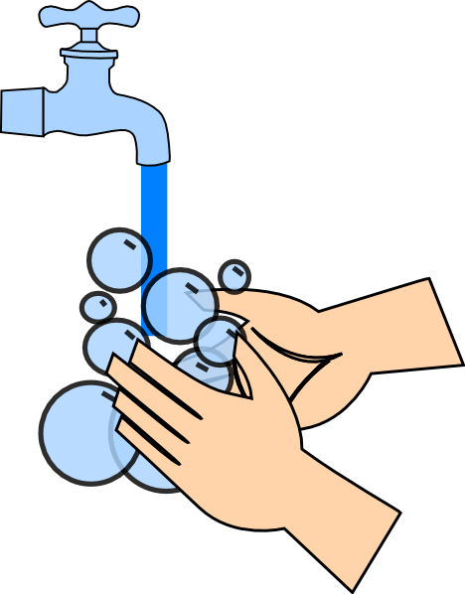

HANDWASHING

- Get hands wet
- Rub hands together with soap, including backs
of the hands and under the nails
- Wash under water for 20 seconds
- Rinse hands
- Dry hands
- Turn off faucet with paper towel

